

MyBenU Direct Deposit Self Service

Employees can now enter and modify their direct deposit information by using the following navigation.

Navigation is: www.ben.edu > click on 3 lines icon in right corner > scroll under “Login Quick Links” to myBenU – PeopleSoft Portal

- www.ben.edu
- Click on three lines icon in right corner 
- Click on myBenU icon 

- Scroll down to Login Quick Links and select myBenU – PeopleSoft Portal
- Login using your daily login credentials

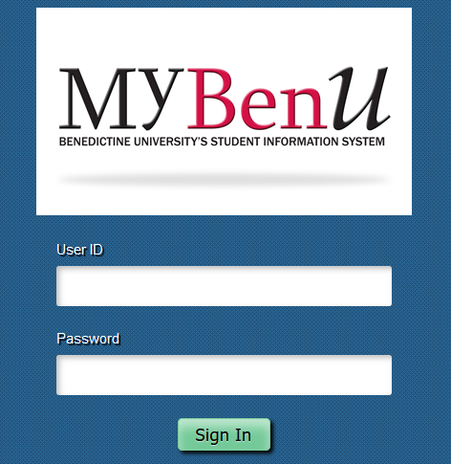

- Click on “Employee Self Service”

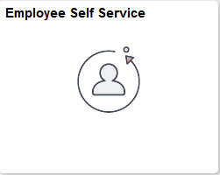

- Click on “Direct Deposit”

- Click on “Add Account”
- Complete the following fields:
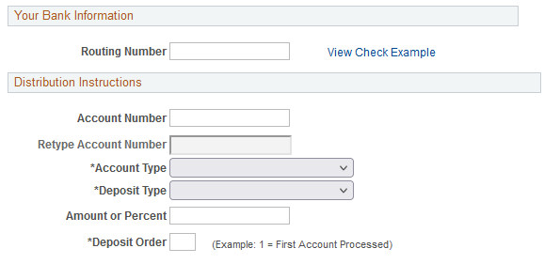
- Routing Number – For checking account, please see example below on what to enter. For Savings account you may want to contact your bank to determine what best to enter, if you do not already have that information handy
- Account Number – For checking account, please see example below on what to enter. For Savings account you may want to contact your bank to determine what best to enter, if you do not already have that information handy

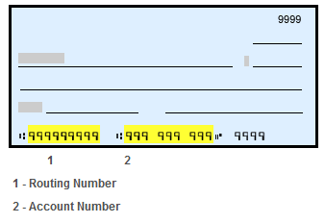
- Account Type – Checking, Issue Check or Savings
- Deposit Type – Amount, Balance of Net Pay or Percent. Note: If you’re setting up multiple types, please ensure that one is designated as “balance type”
- Amount or Percent – If “Balance” is selected as “deposit type” than this can be left blank
- Deposit Order – A deposit order “1” will be first, deposit order “2” will be second, etc. For deposit type “balance” a deposit order “999” is where it will be defaulted in. For example, if you select $500 to go to your savings account as a deposit order “1” and the “balance” to go to a checking account, if your net pay for the pay period is only $400, all $400 will be deposited to your savings account because it had a deposit order of “1” or first.
- Read the terms and conditions:
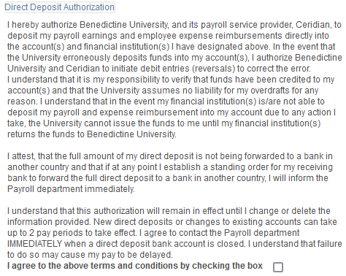

- Click “submit”
- Review your setup to ensure accuracy or to edit, see example below
